Ai_phase5

Fake news detection using nlp

Development part 3

Document submission

There are several innovative techniques and approaches that can be used for fake news detection using NLP in artificial intelligence. Here, I'll mention a few commonly used techniques along with their corresponding code snippets:

1. Bag of Words (BoW) with TF-IDF:

The Bag of Words approach can be used to convert text data into numerical vectors. TF-IDF (Term Frequency-Inverse Document Frequency) is then applied to these vectors to represent the importance of words in documents. Here's an example using Python's sklearn library:

python

from sklearn.feature_extraction.text import TfidfVectorizer

# Tokenize and preprocess the text data

processed_text = [' '.join(tokenize(text)) for text in dataset]

# Convert text to TF-IDF vectors

vectorizer = TfidfVectorizer()

tfidf_matrix = vectorizer.fit_transform(processed_text)

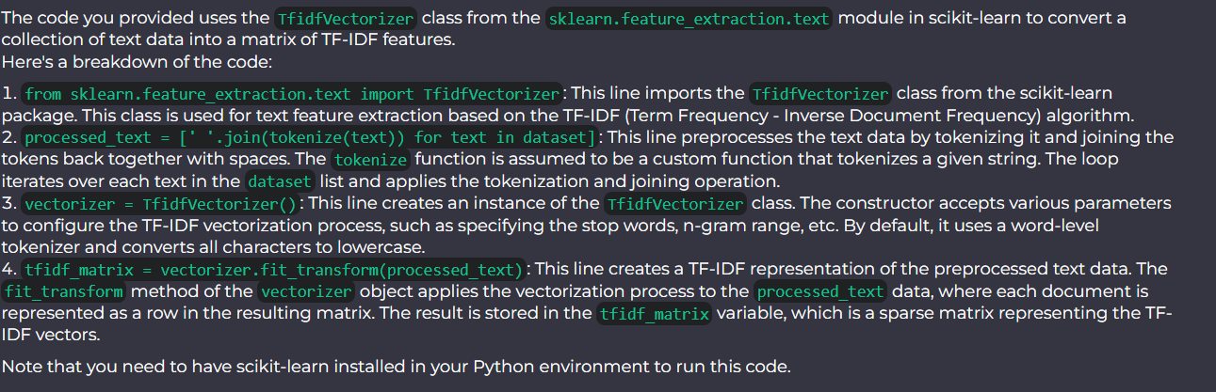

2. Word Embeddings with Word2Vec:

Word embeddings represent words as dense vectors in a continuous vector space. Word2Vec is a popular technique used to learn word embeddings from large text corpora. Here's an example using the Gensim library in Python:

python

from gensim.models import Word2Vec

# Generate word embeddings using Word2Vec

model = Word2Vec(dataset, size=100, window=5, min_count=1)

# Get the vector representation of a word

word_vector = model.wv['example']

3. LSTM-based Models for Text Classification:

LSTM (Long Short-Term Memory) is a type of recurrent neural network that can capture long-term dependencies in sequential data. It is commonly used for text classification tasks. Here's an example of an LSTM-based model using the Keras library in Python:

python

from keras.models import Sequential

from keras.layers import Embedding, LSTM, Dense

# Define the LSTM-based model architecture

model = Sequential()

model.add(Embedding(vocab_size, 100, input_length=max_sequence_length))

model.add(LSTM(100))

model.add(Dense(1, activation='sigmoid'))

# Compile and train the model

model.compile(loss='binary_crossentropy', optimizer='adam', metrics=['accuracy'])

model.fit(X_train, y_train, epochs=10, batch_size=32)

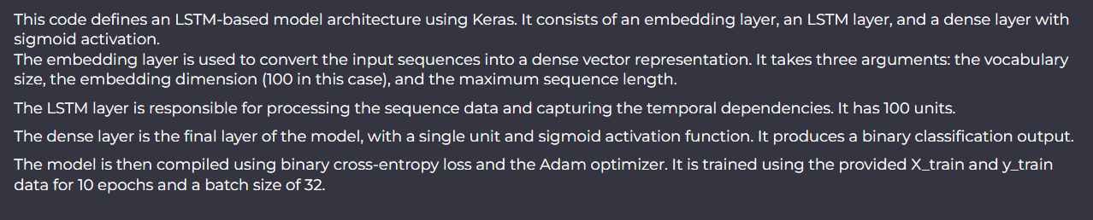

These are just a few examples of innovative techniques and approaches used for fake news detection. Depending on the specific requirements and available data, other methods such as attention mechanisms, transformer models, or graph-based approaches can also be explored.